NEEDS!

Everything you need in one click!

Group Members:-

Rahul Raina-20103082-B3

Gautam Grover-20103068-B3

Aditya Gaur-20103066-B3

Hardik Bahri-20103088-B3

**INTRODUCTION:-**

As we know, how much people suffered for basic needs like Oxygen, Oxygen Cylinders, Beds, ICU Beds,

Medicines especially Remdesivir and many other basic needs which were life-saving and couldn’t reach

to many in time.

People were so desperate that they were paying 10-20 times of the medicines/oxygen cylinders and

were travelling to different states to find the basic necessities and hospital beds.People were running

here and there looking after vaccinations..

So in a bid that this situation does arise again, we are making a web-page that takes the users location

and shows the item asked by the user. For example if the user asks for hospital beds near his/her

locality, we would show all the hospitals registered in the user’s locality and would display the no. of

beds available in the respective hospitals.

If the user asks for medicine shops, Oxygen, Life Saving Drugs near the user’s locality, the respective

data would be displayed to the user, even providing if that particular shop has the stock for certain

medicine or not.

We will also provide the vaccination data near the user’s locality or of any pin-code entered by the user.

We would even display the no. of slots available in the vaccination center.

We have also given an option for volunteering, if the user wishes to volunteer either monetarily or in

any other form, we have attached a google form so that we can take users details and communicate

accordingly with the user.

**ER Diagram-**

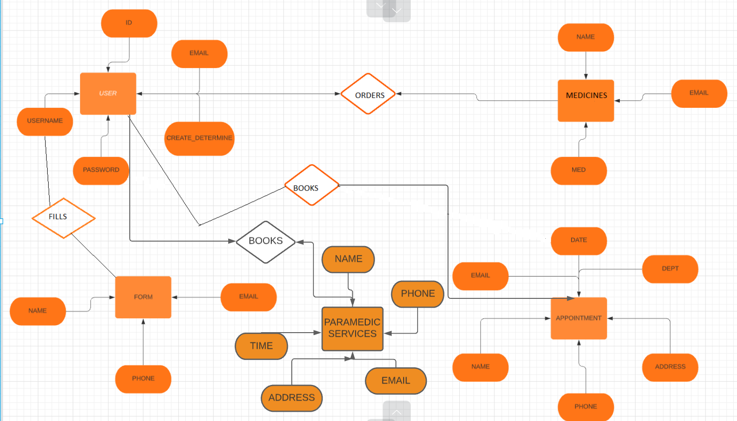

**Snapshots of the website-**

**INDEX.PHP:-**

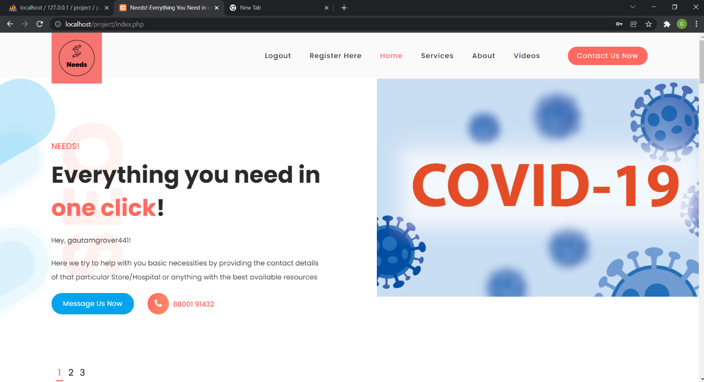

**LOGIN.PHP:-**

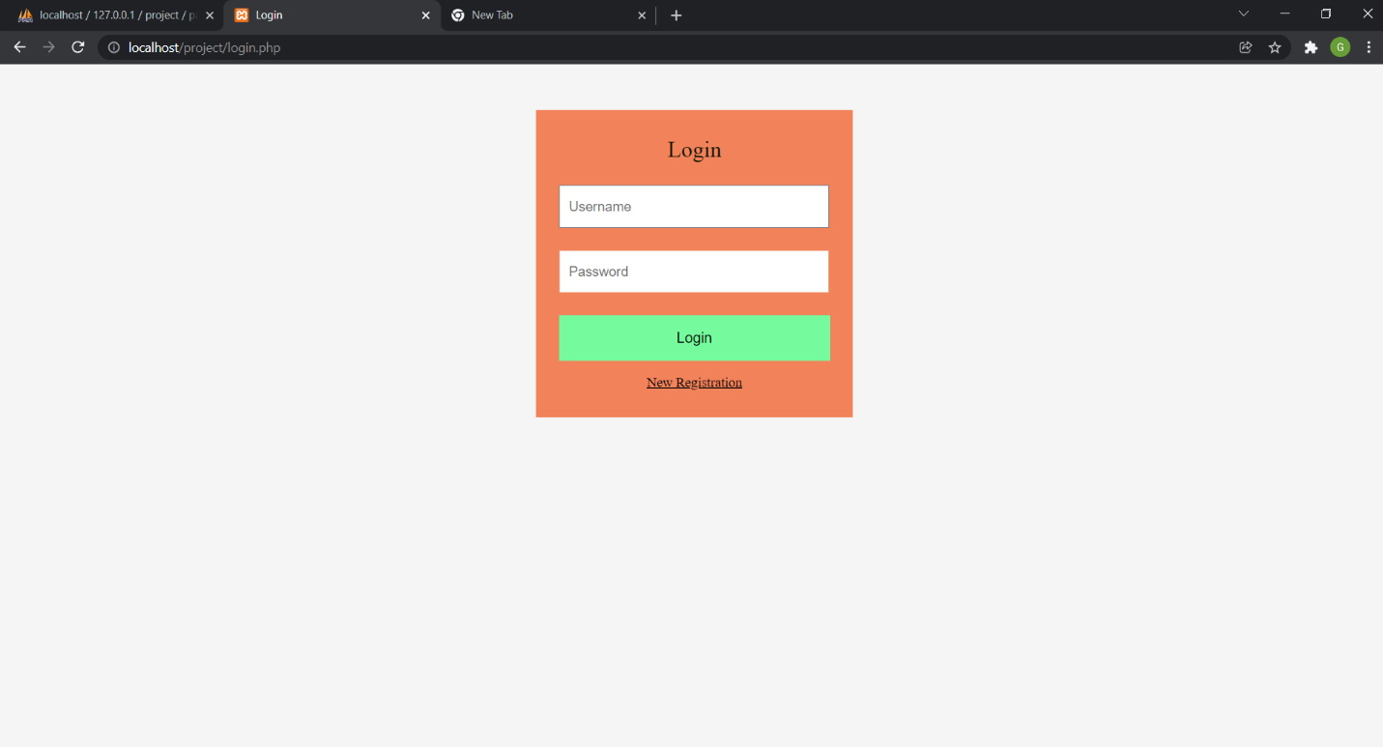

**REGISTRATION.PHP:-**

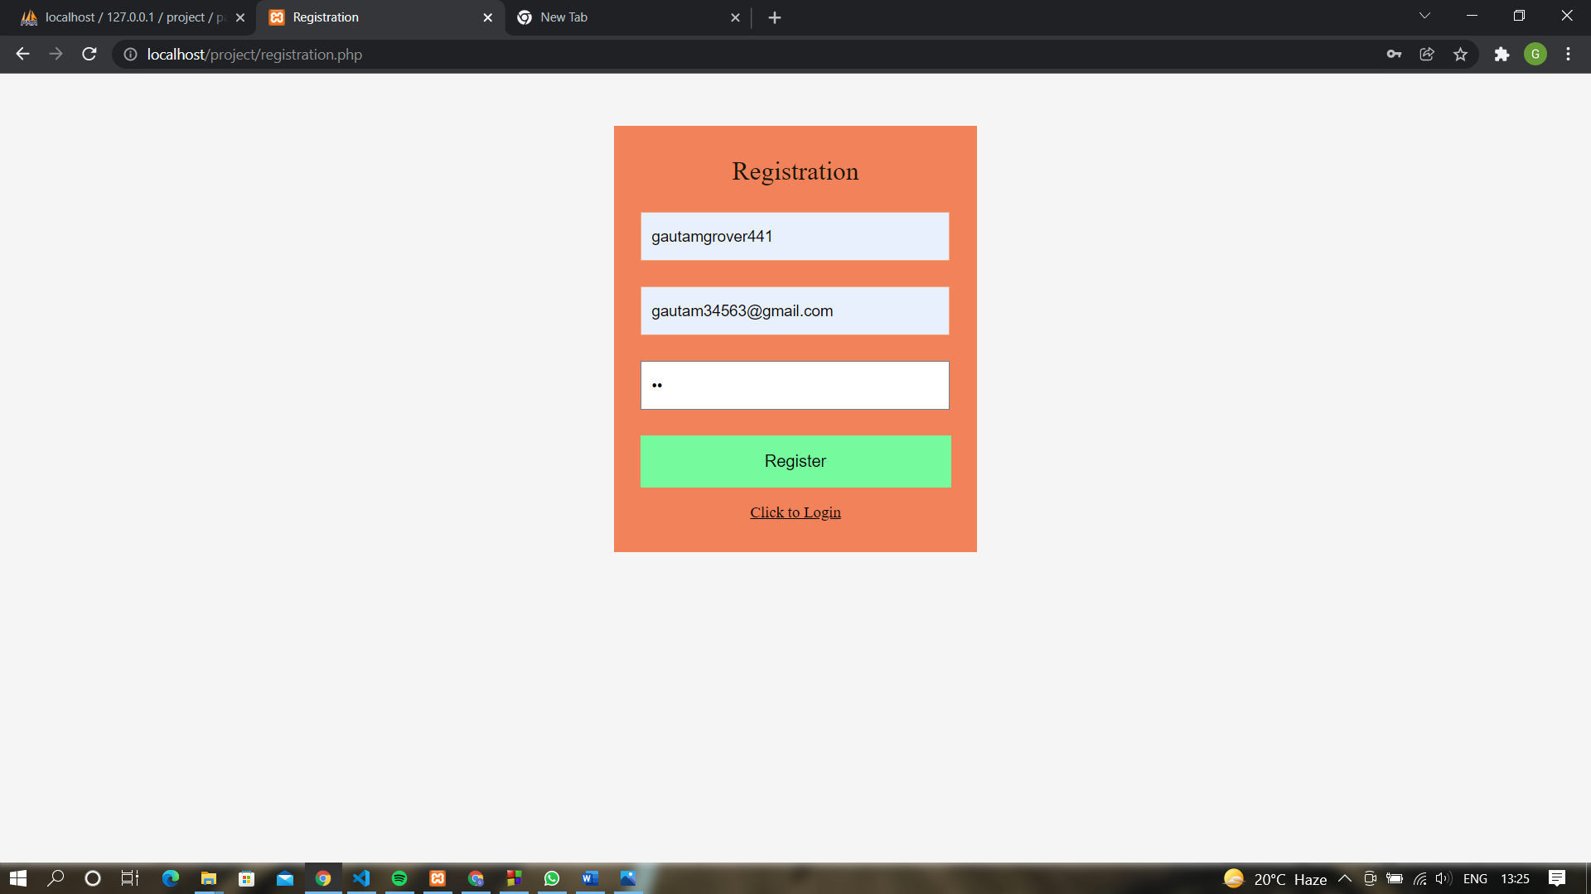

**VALUES STORED IN USER TABLE:-**

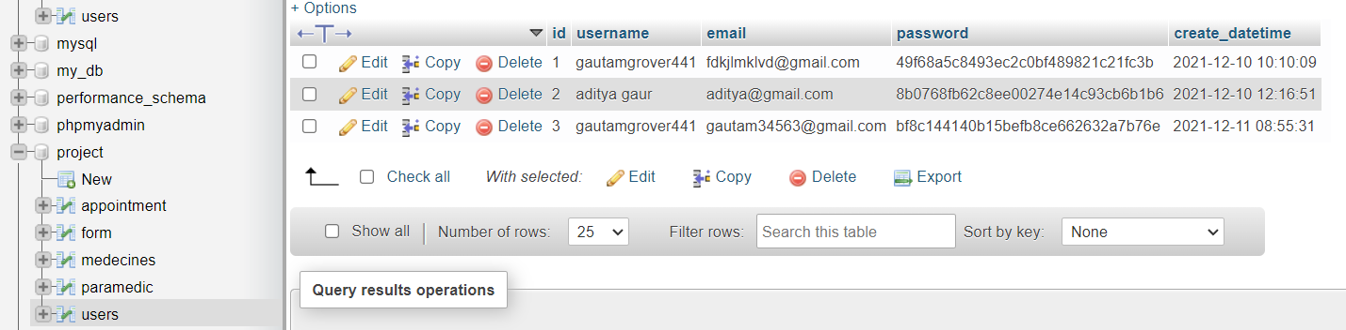

**INDEX.PHP FORM:-**

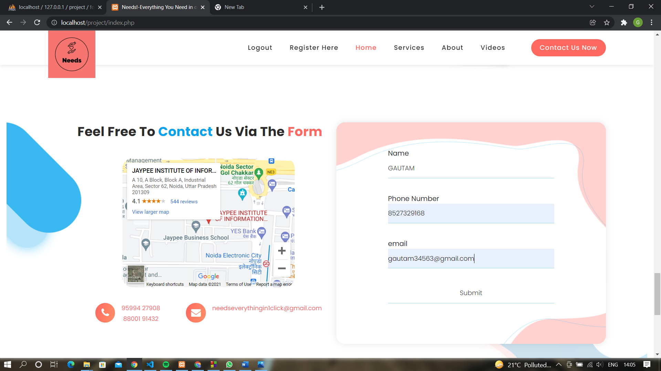

**FORM TABLE:-**

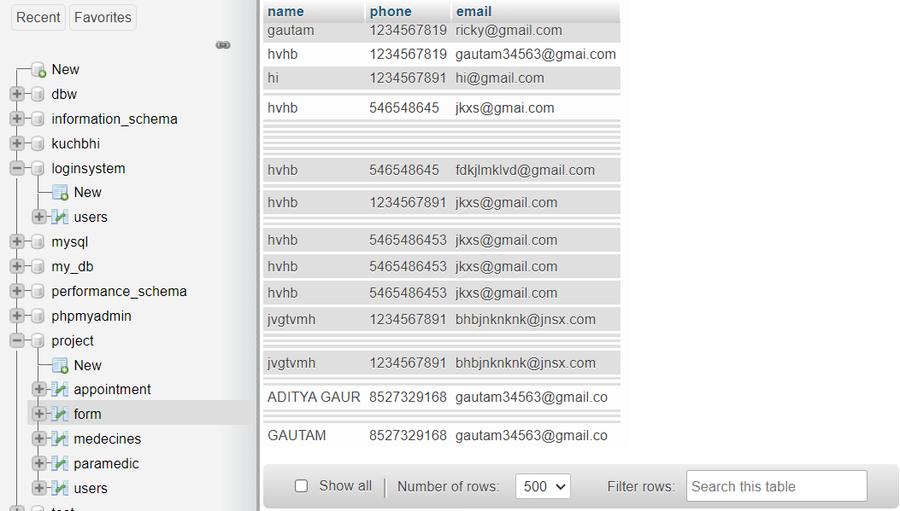

**APPOINTMENT.PHP:-**

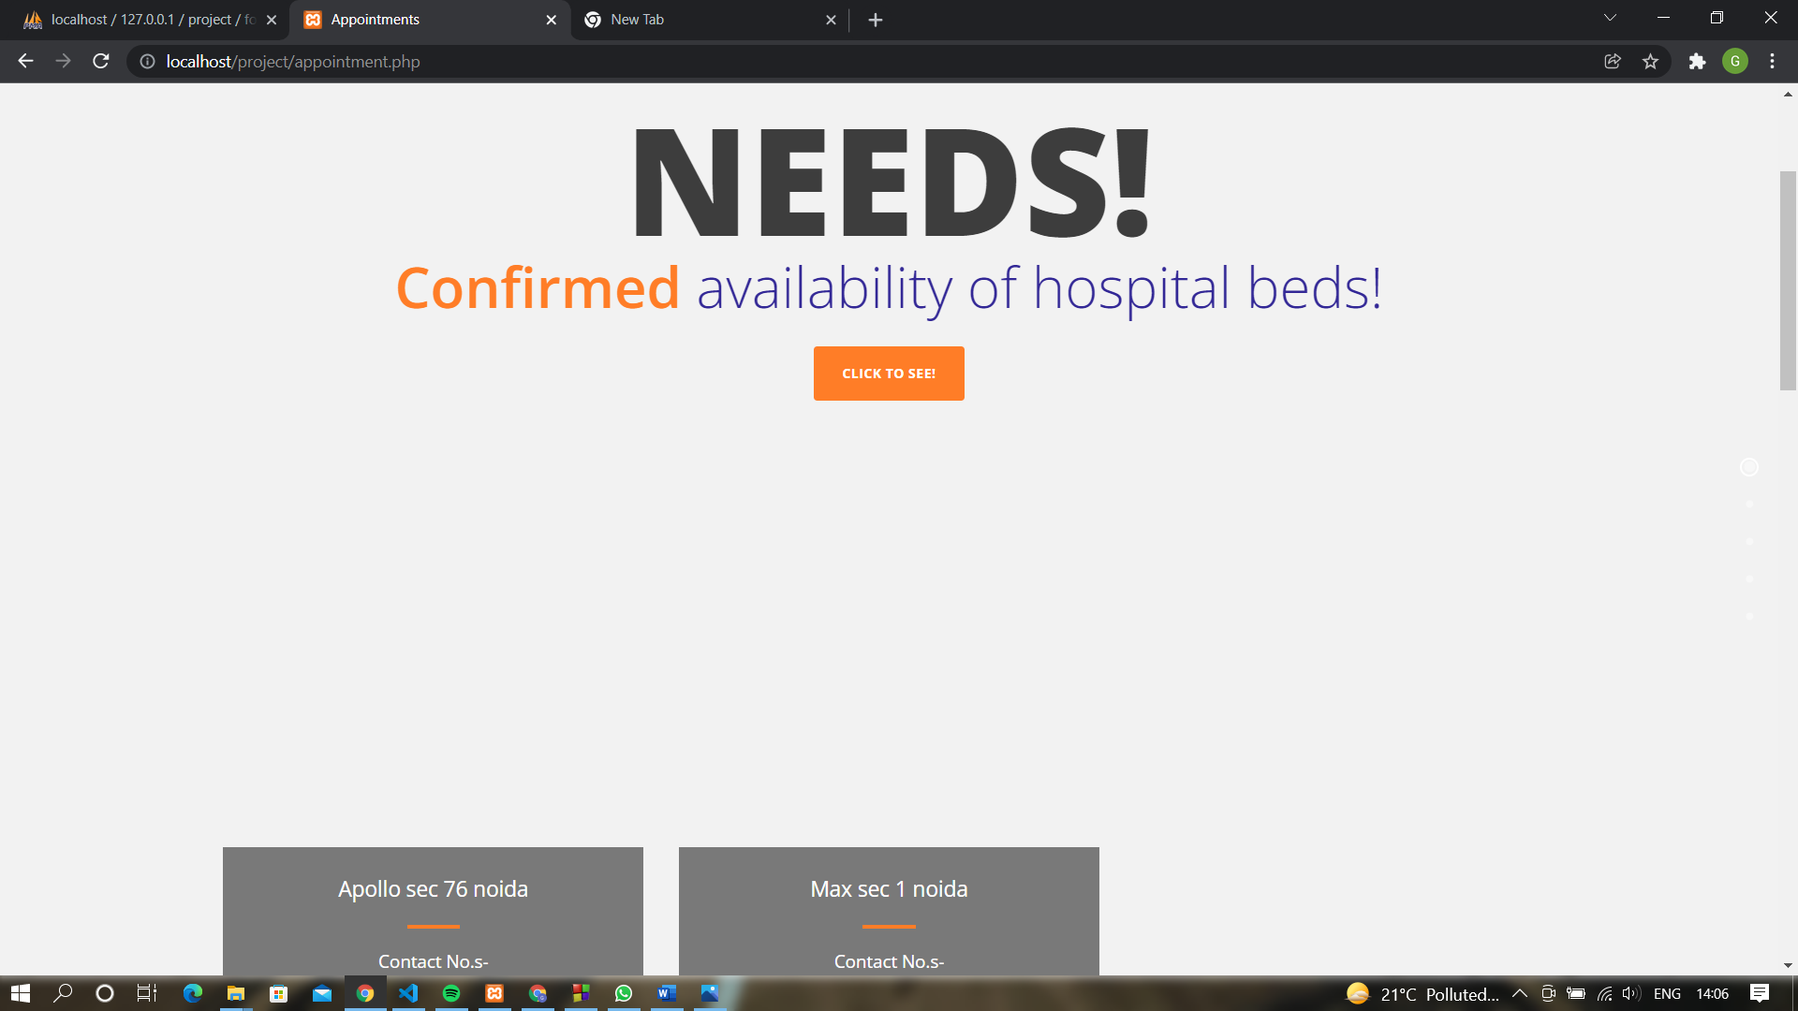

**APPOINTMENT FORM:-**

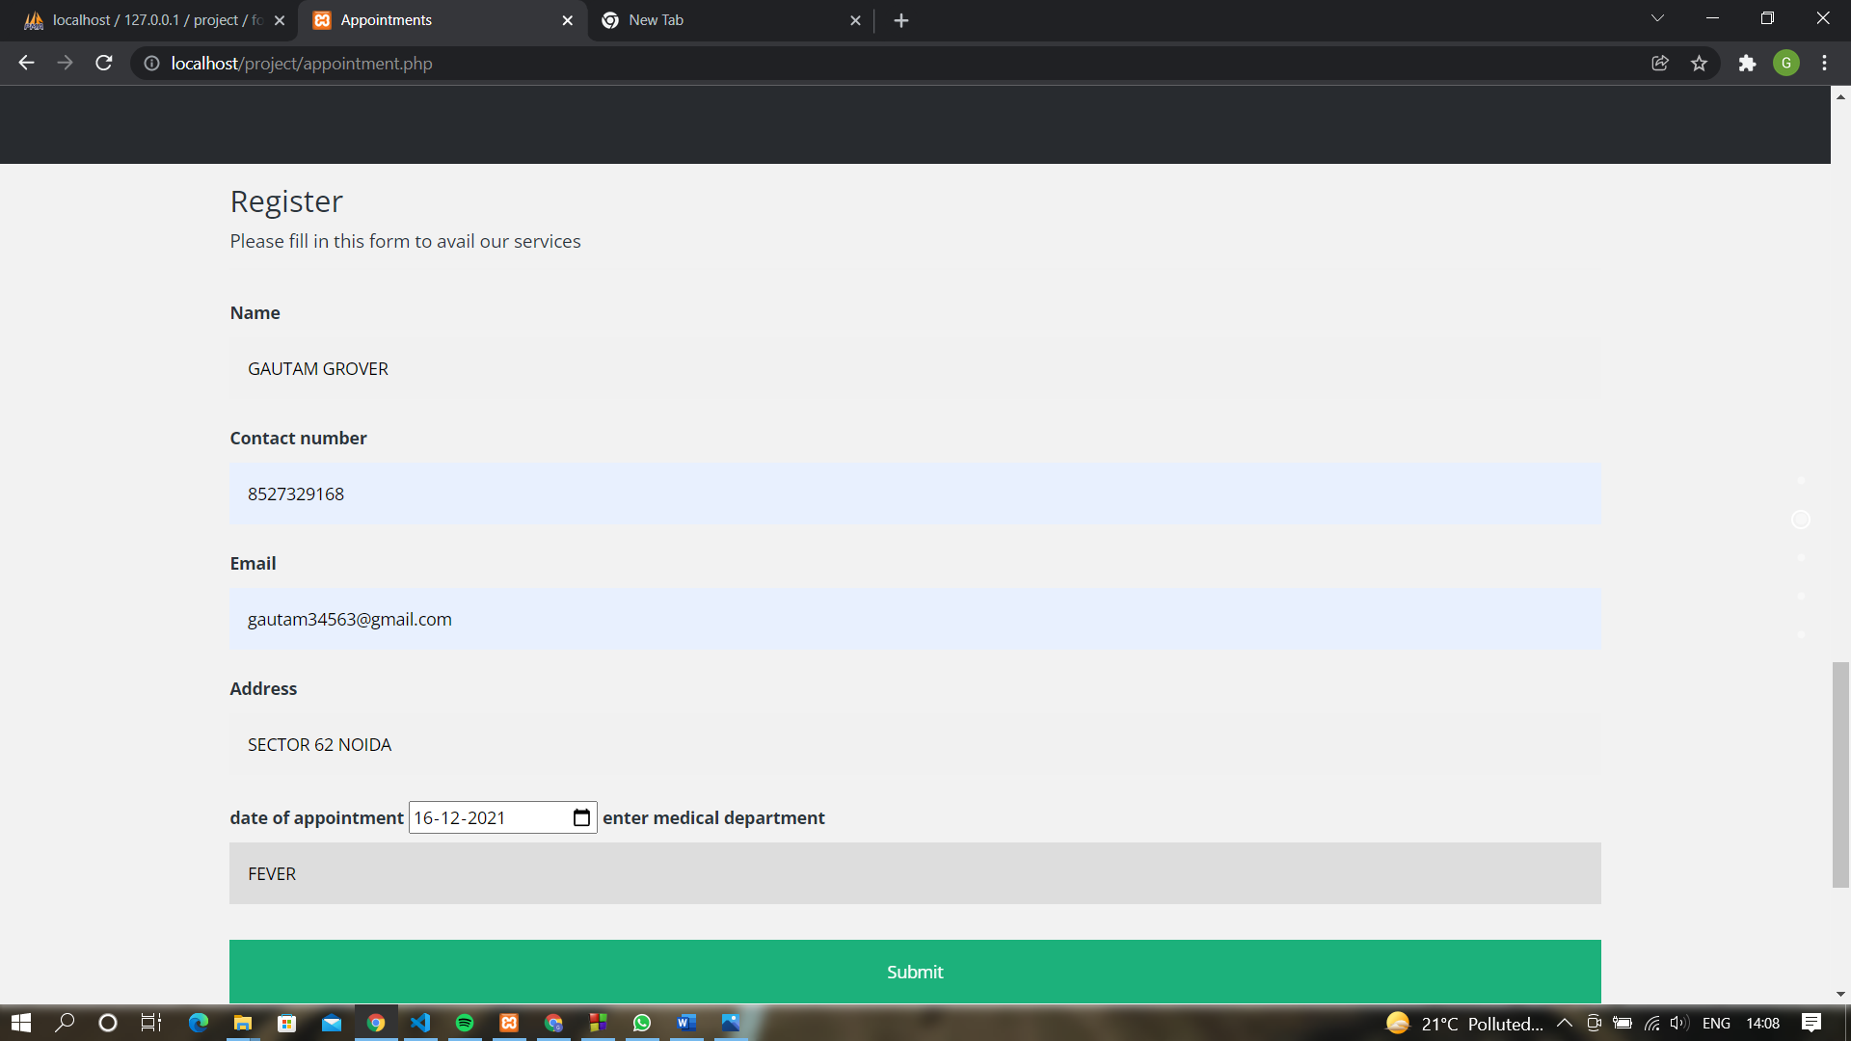

**APPOINTMENT TABLE:-**

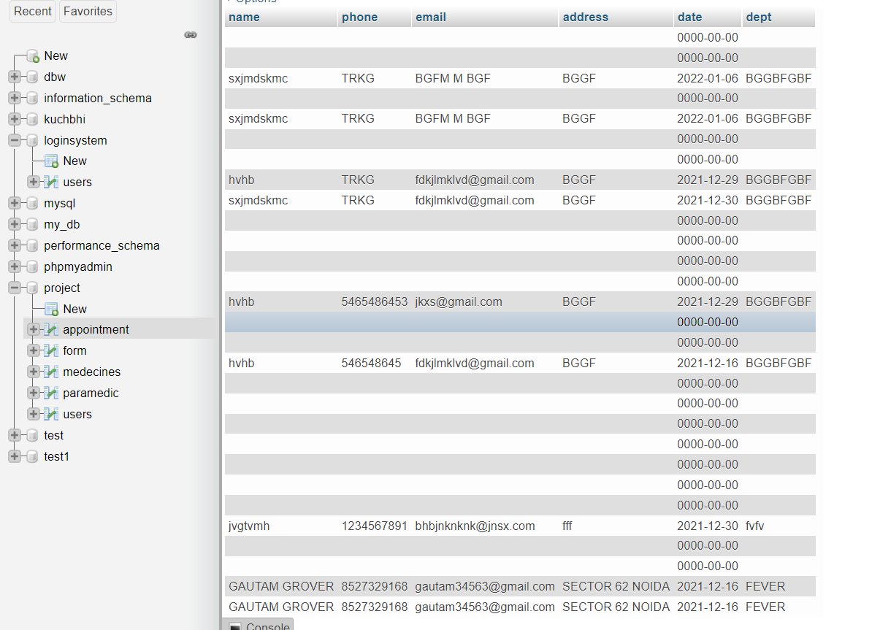

**MEDICINES.PHP**

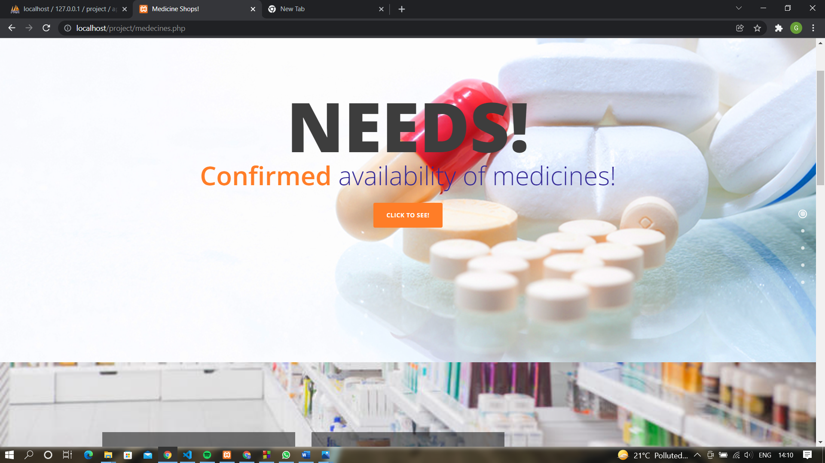

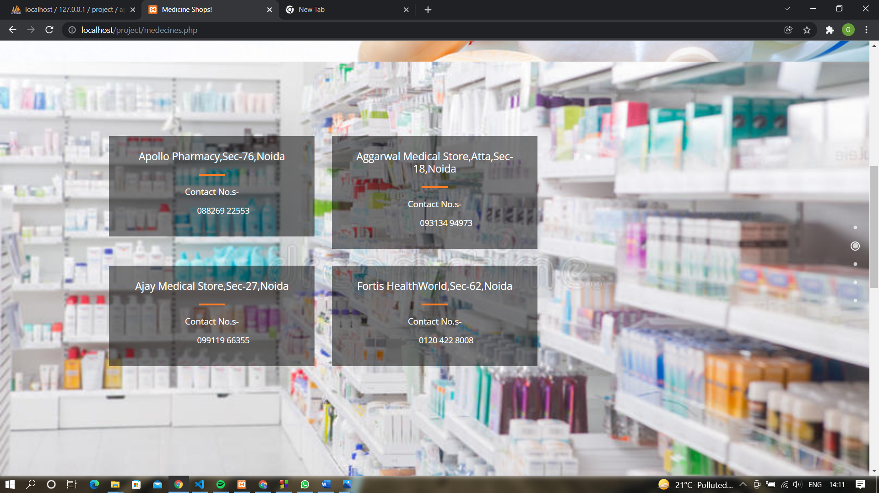

**MEDICINES FORM:-**

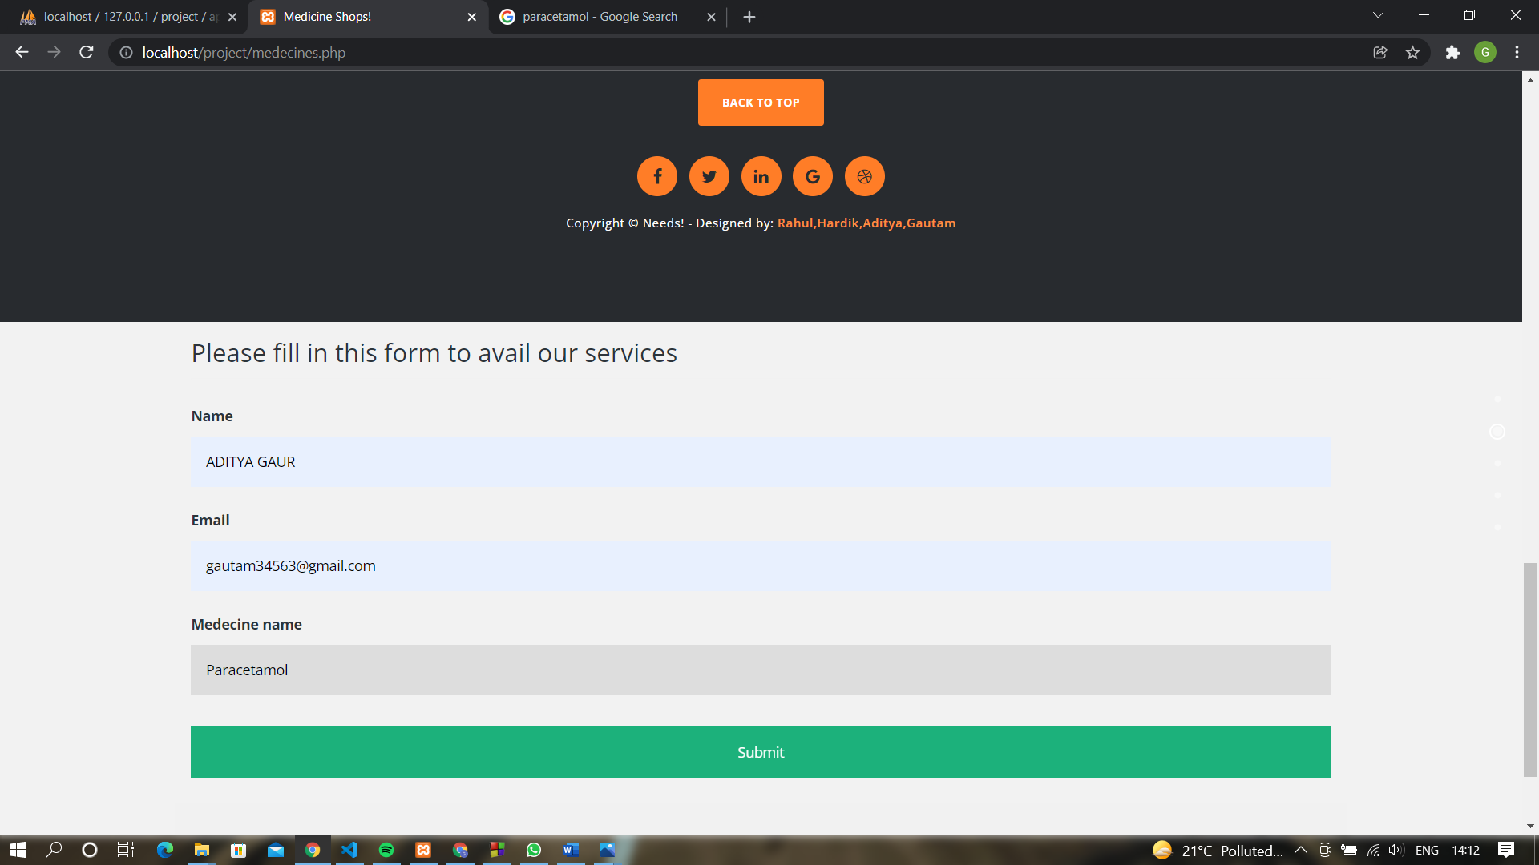

**MEDICINES TABLE:-**

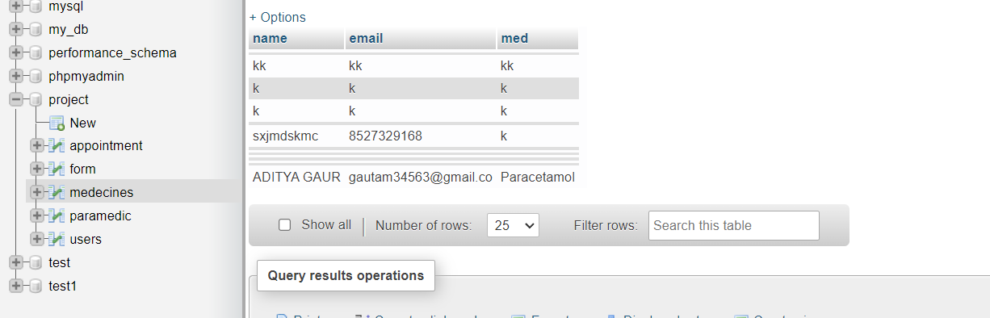

**OXYGEN.HTML:-**

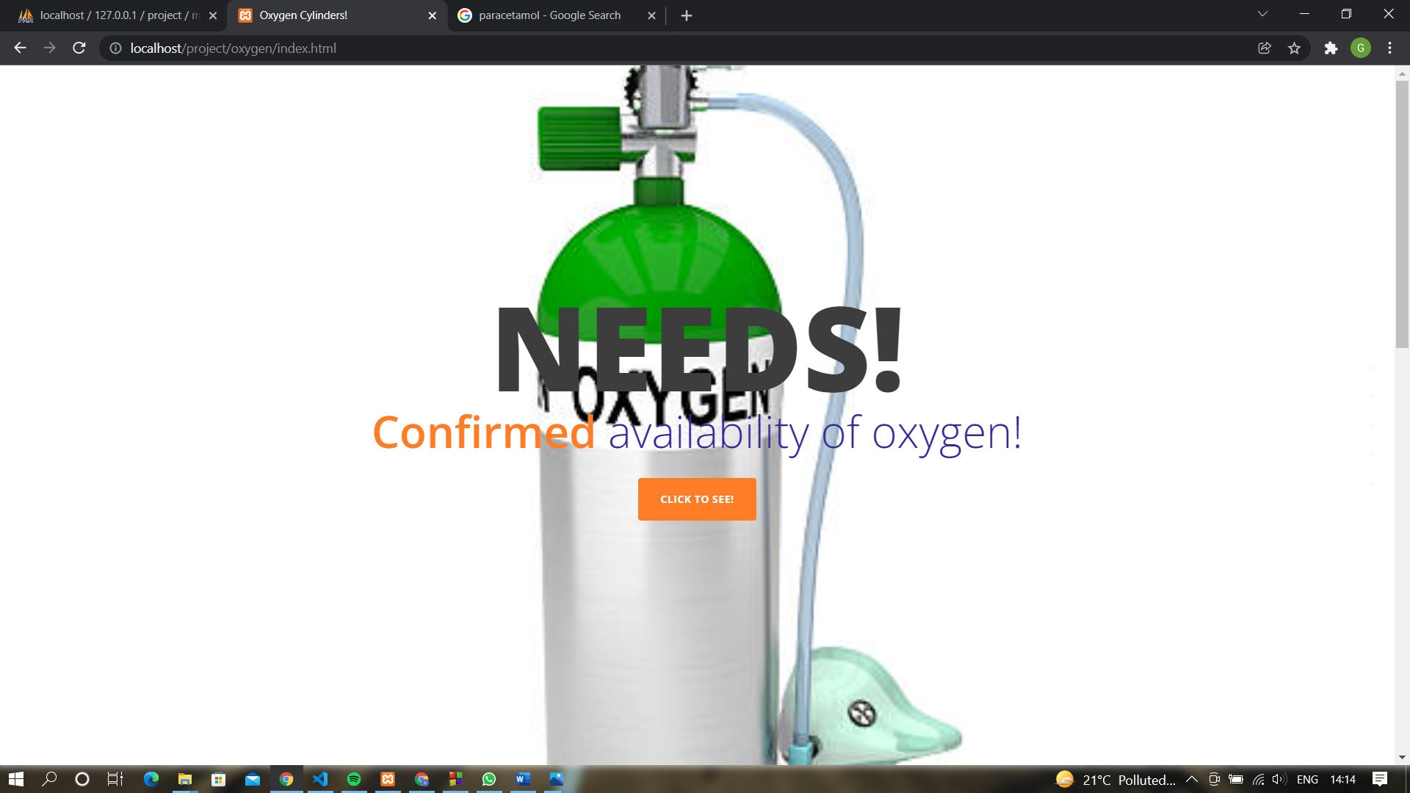

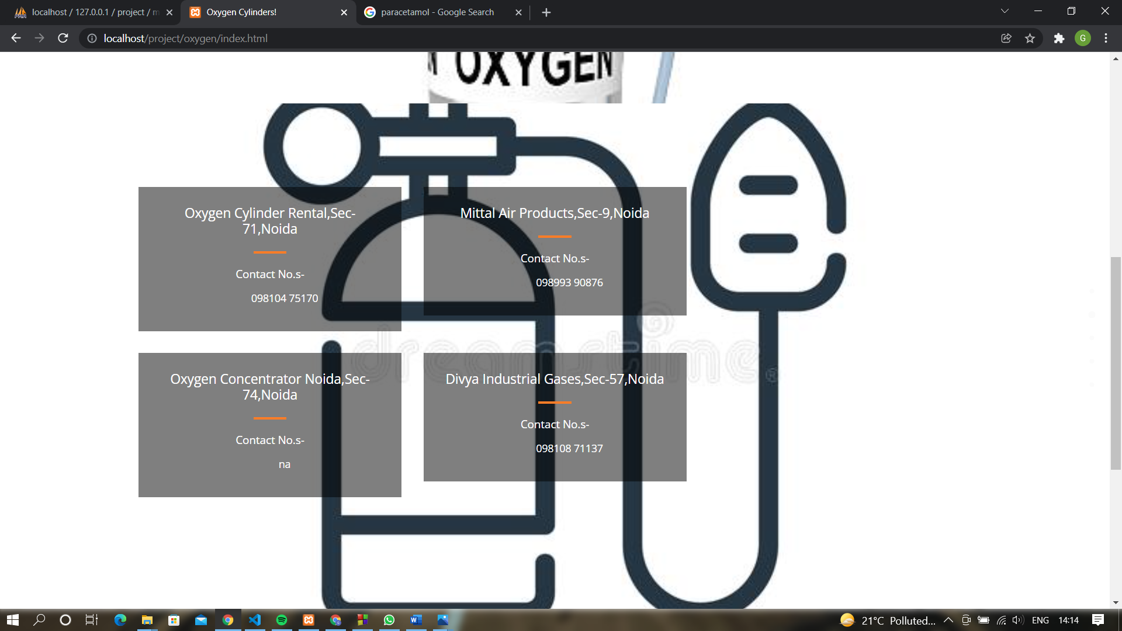

**PARAMEDIC SERVICES.PHP:-**

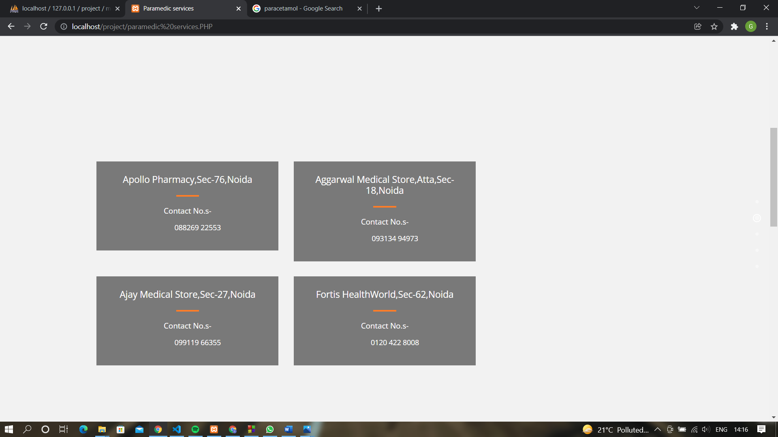

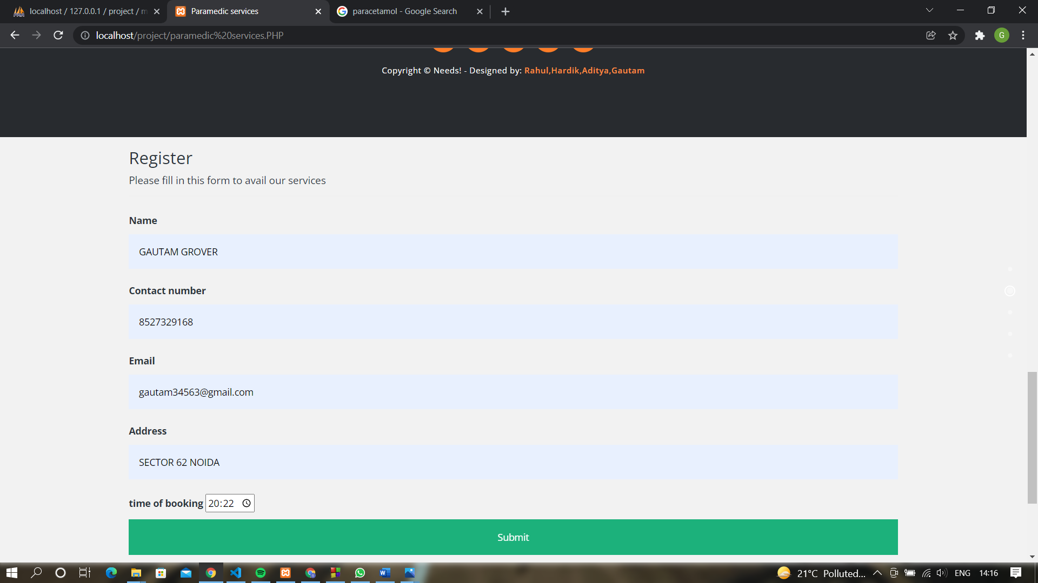

**PARAMEDIC TABLE:-**

